Practical 9
Aim : Install IPFS locally on our machine, initialize your node, view the nodes in network and add files and directories install Swarm and run any test file.

Introduction :
IPFS (InterPlanetary File System) is a decentralized, peer-to-peer file storage and sharing system. Instead of storing files on a single central server, IPFS stores and retrieves files using a unique CID (Content Identifier). It allows users to share files directly between connected nodes.

Steps :
Step 1 : Download and install IPFS Kubo and check version.
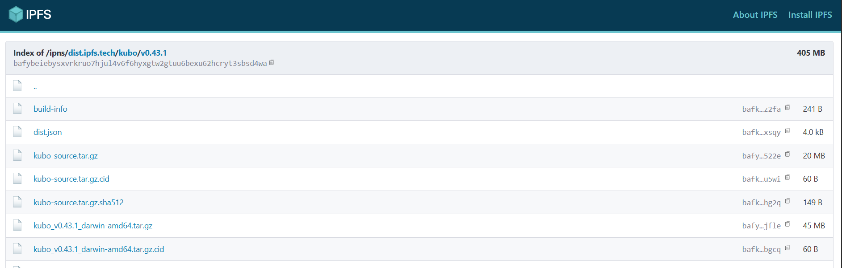
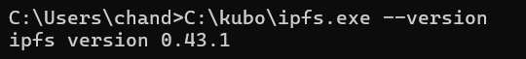

Step 2 : Initialize Node.
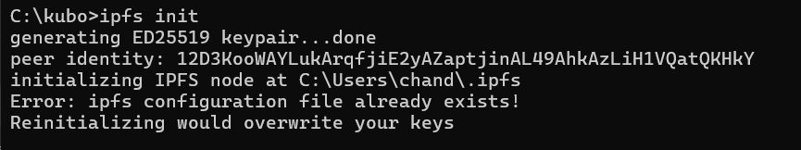

Step 3 : Start IPFS.
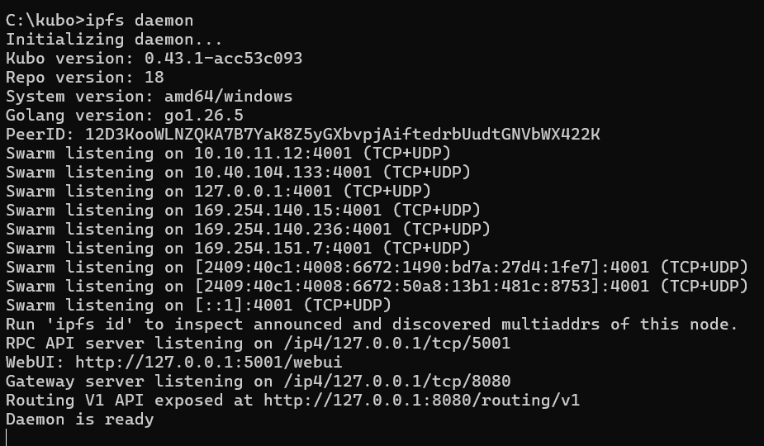

Step 4 : View Node and Network.
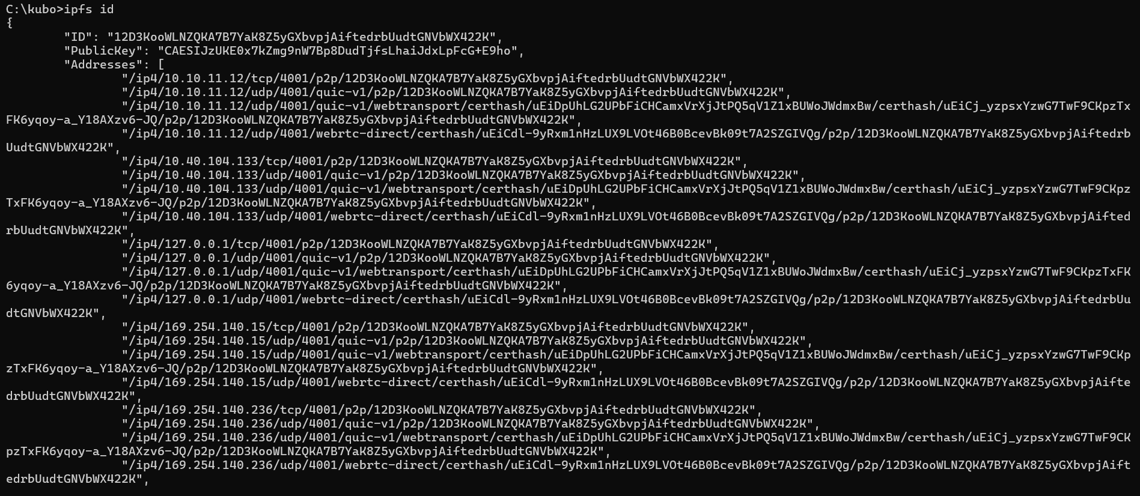
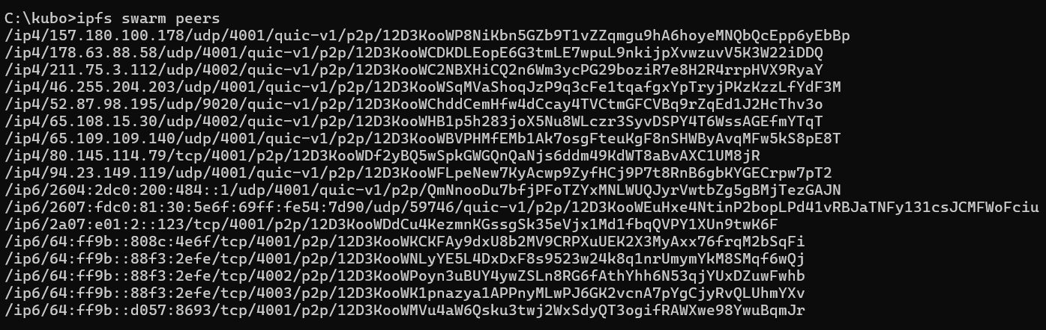
Step 5 : Create and Add a Test File.

Step 6 : Read the File.

Step 7 : Add a Directory.
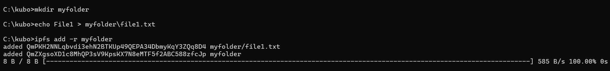

Step 8 : Test Swarm.
